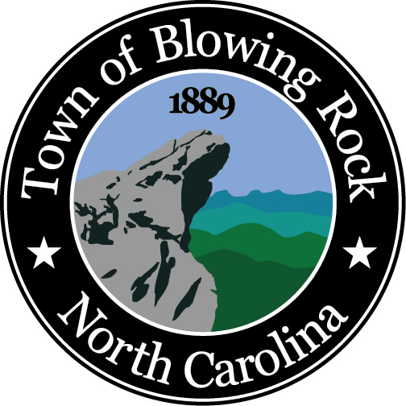
TOWN OF BLOWING ROCK
PO Box 47
Blowing Rock, NC 28605
Telephone: (828) 295-5240 Fax: (828) 295-0357
www.townofblowingrock.com

VARIANCE APPLICATION

- Applicant:

Address:

Phone: Fax:

- Owner, if different from Applicant:

Address:

Phone: Fax:

- Describe request:

- Property address:

- PIN: Property Zoning District:

For variance request please attach a site plan showing: (a) lot dimensions, (b) required setbacks, (c) setbacks requested, (d) elevations, (e) surrounding streets, (f) proposed construction footprint.

Applicant Signature: Date:

Completed by Staff:

Date Received_____________ Fee Paid $___________ Paid by____________ Staff Initials_______

IMPORTANT INFORMATION ON THE BACK

TOWN OF BLOWING ROCK
VARIANCE PROCEDURE

The following is required for each applicant requesting a variance.

- Conference with the Zoning Administrator before formal application.
- Complete application and fee.
- Site Plan (to scale) showing lot, dimensions, required setbacks requested, elevations, surrounding streets, proposed construction and septic system if applicable.
- Submit application, site plan and current applicable fee (fee must be paid prior to any advertising).
- Stake out proposed construction with stakes and visible markers to show where building or structure will be located.

Section 16-5.2. A variance from the requirements of the Land Use Ordinance may be granted by the Board of Adjustment if it determines, by a 4/5 majority, the following determinations:

When unnecessary hardships would result from carrying out the strict letter of these regulations, the board of adjustment shall vary such regulations upon a showing of all of the following:

(a) Unnecessary hardship would result from the strict application of the regulations. It shall not be necessary to demonstrate that, in the absence of the variance, no reasonable use can be made of the property.

(b) The hardship results from conditions that are peculiar to the property, such as location, size, or topography. Hardships resulting from personal circumstances, as well as hardships resulting from conditions that are common to the neighborhood or the general public, may not be the basis for granting a variance.

(c) The hardship did not result from actions taken by the applicant or the property owner. The act of purchasing property with knowledge that circumstances exist that may justify the granting of a variance shall not be regarded as a self-created hardship.

(d) The requested variance is consistent with the spirit, purpose, and intent of the regulations, such that public safety is secured, and substantial justice achieved. Substantial justice is not achieved when granting the variance would be injurious to the neighborhood or to the general welfare.

Contact the Planning and Inspections office at 828-295-5240 if you have any questions with the variance procedure.

